CV

1) Personal information:
-Name and Surname: Mahfoudh Saidi
-Address :University of kairouan-tunisia
-Email: mahfoudhsaidi2013@yahoo.fr
-agregamhfoudh2017@gmail.com
2) Personal Data:
-Nationality: Tunisia
-sex: male
- The US EMBASSY IN TUNISIA GAVE ME VISA FOR 10 years (2019-2029)

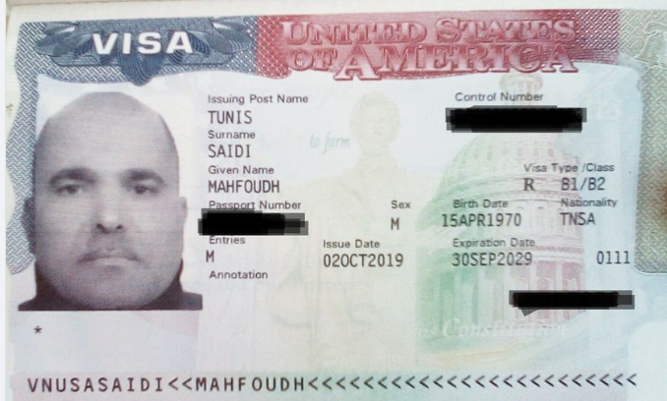

3) SCIENTIFIC DIPLOMS AND DEGREES:
-BACHELAR OF PHILOSOPHY:I obtained the first RANK in the Tunisian republic and i received the award of the president of Republic
-MASTER of philosophy :with a very good note and observation
-AGGREGATION IN PHILOSOPHY
-PHD In human and social sciences
Observation: VERY HONORABLE
-Higher Uiversity Degree in Psychology
I’m the only in Tunisia who have four higher Diploms
4) Skills:
I have a good work experience in the world of Administration ad especially in the position of nurse manager for Case Management.
I will use all my scientific and administrative skills in order to participate in your project of the pursuit of positive change through the transformative power of people ad ideas. and I will be in the degree of your aspirations and objectives

-I published my2books of philosophy of ethics
Actually ,i teach Philosophy of sciences at the tunisian university.i have 19 years in yhis job in tunisian university.
- i published many scientific manuscriptsabout the subject of philosophy in some indexed journals. one of them was indexed in Scopus and Elsevier like USRIJ
- i presented and i gave a conference at the UCSB in california last october2019
-I participated in the Marcuse conference in 2021 and gave a virtual lecture at the University of Arizona, USA
- i have a higher diplomate of PEDAGOGY and Psychology
b) linguistic SkILLS :
-my skills in teaching with English language are excellent
5°)OBBJECTIVES :
-teaching philosophy of ethics in your great university
-writing philosophical books
-To encourage my scientific research , my participation in scientific conferences and my presentation of lectures in American universities, the United States of America granted and gave me a 10-year visa.

-The University of Arizona, United States of America, gives me a certificate of thanks for my participation in my lecture entitled Technology and counter technology in the Marcuse's dialectic of technology, which I presented at the International Scientific Conference on Herbert Marcuse.

